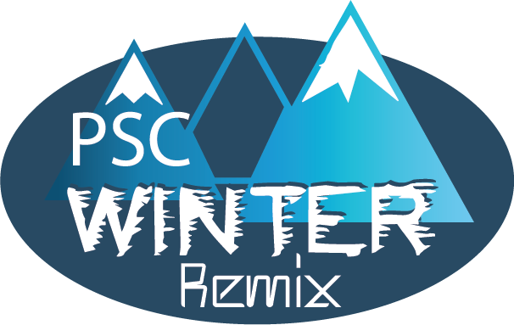

**What to bring List**

**2023 Jr./Sr. High Winter Retreat**

**What to bring**

*Sleeping bag and pillow or sheets and blanket

*Toiletries (toothbrush, soap, towel, etc.)

*Winter snow clothing—we will be playing outside, even in the snow, pack for plenty of layers!

*Snow boots and sneakers for indoor activities

*Clothes appropriate for camp in the winter.

*Bible, Journal or Notebook, and a pen or pencil

*Flashlight

*Camera (optional)

*Medication if necessary. Please label all medications

**What not to bring**

* Cell phone, gaming devices, etc.

etc. You will NOT need them!

*Food (including gum)

*Knives and other weapons

**Medications**

Any and ALL medications should be turned in when you check in on Friday night to our nurse. The camp nurse will make sure that prescription medications are given when required. The camp cannot be responsible for medications that are not turned in at registration time!!